**AI-POWERED NUTRITION ANALYZER FOR FITNESS**

**ENTHUSIASTS**

**DOMAIN : ARTIFICIAL INTELLIGENCE**

### TEAM ID : PNT2022TMID36947

**PROJECT REPORT**

**submitted by**

**B.MAGUDAPATHY 211919104004 Computer science& Rajiv Gandhi College**

**Engineering of Engineering**

**R.SARAVANAN 21191906005 Electronics&**

**communication Rajiv Gandhi College**

**Engineering of Engineering**

**E.MUTHU 211919104007 Computer science& Rajiv Gandhi College**

**Engineering of Engineering**

**V.RAGUL 211919104305 Computer science& Rajiv Gandhi College**

**Engineering of Engineering**

### TABLE OF CONTENTS

1. **INTRODUCTION ..........................................................................................................................**
   1. Project Overview ............................................................................................................................
   2. Purpose ...........................................................................................................................................
2. **LITERATURE SURVEY................................................................................................................**
   1. Existing problem .............................................................................................................................
   2. References .......................................................................................................................................
   3. Problem Statement Definition .........................................................................................................
3. **IDEATION & PROPOSED SOLUTION.......................................................................................**
   1. Empathy Map Canvas.......................................................................................................................
   2. Ideation & Brainstorming.................................................................................................................
   3. Proposed Solution.............................................................................................................................
   4. Problem Solution fit..........................................................................................................................
4. **REQUIREMENT ANALYSIS.........................................................................................................**
   1. Functional requirement.....................................................................................................................
   2. Non-Functional requirements...........................................................................................................
5. **PROJECT DESIGN..........................................................................................................................**
   1. Data Flow Diagrams..........................................................................................................................
   2. Solution & Technical Architecture....................................................................................................
   3. User Stories.......................................................................................................................................
6. **PROJECT PLANNING & SCHEDULING....................................................................................**
   1. Sprint Planning & Estimation............................................................................................................
   2. Sprint Delivery Schedule...................................................................................................................
   3. Reports from JIRA.............................................................................................................................
7. **CODING & SOLUTIONING (Explain the features added in the project along with code)**
   1. Feature 1
   2. Feature 2
8. **TESTING** 
   1. Test Cases
   2. User Acceptance Testing
9. **RESULTS**
   1. Performance Metrics
10. **ADVANTAGES & DISADVANTAGES**
11. **CONCLUSION**
12. **FUTURE SCOPE**
13. **APPENDIX**

Source Code

GitHub & Project Demo Link

**1.INRODUCTION**

#### 1.1 Project Overview

Food is essential for human life and has been the concern of many healthcare conventions. Nowadays new dietary assessment and nutrition analysis tools enable more opportunities to help people understand their daily eating habits, exploring nutrition patterns and maintain a healthy diet. Nutritional analysis is the process of determining the nutritional content of food. It is a vital part of analytical chemistry that provides information about the chemical composition, processing, quality control and contamination of food.

The main aim of the project is to build a model which is used for classifying the fruit depends on the different characteristics like colour, shape, texture etc. Here the user can capture the images of different fruits and then the image will be sent the trained model. The model analyses the image and detect the nutrition based on the fruits like (Sugar, Fibre, Protein, Calories, etc.).

##### 1.2 Purpose

Nutrition Analyzer helps in the detailed and perfect determination of the component nutrients present in any food item. Food components have vast bio metabolic roles and could affect human health severely.

Purpose of the AI powered Nutrition Analyzer is to help individuals who needs a proper nutrition assistant to achieve fitness ,to cure diseases through foods or to lead a healthy lifestyle. With the help of Artificial Intelligence , it was possible to achieve a proper nutrition analyzer which is capable of showing the nutrition content of the food when we give the picture of it.

**2.LITERATURE SURVEY**

#### 2.1 Existing Problem

Controlled intake of nutrition is recommended as a condition for being a healthy individual. Knowing and monitoring how much food is consumed during the day, following the calorie and nutrition of these foods helps to control healthy nutrition. However there is no proper assistance to achieve it. Nutritional intake is fundamental to human growth and health, and the intake of different types of nutrients and micro-nutrients can affect health. The content of the diet affects the occurrence of disease, with the incidence of many diseases increasing each year while the age group at which they occur is gradually decreasing. The consumption of a wide variety of food items is necessary in order for the human body to obtain the right amounts of nutrients. Failing to follow such a well- balanced diet, in combination with a generally unhealthy way of living, has been shown to increase the risk for cardiovascular disease, type II diabetes and some forms of cancer.

#### 2.2 References

1.“Approximate Estimation of the Nutritions of Consumed Food by Deep Learning” by İbrahim Berkan Aydilek Published in [2017 International Conference on Computer Science and Engineering (UBMK),](https://ieeexplore.ieee.org/xpl/conhome/8082159/proceeding) IEEE, 2017.

2.“Validation of a deep learning system for the full automation of bite and meal duration analysis of experimental meal videos”D Konstantinidis, K Dimitropoulos, B Langlet, PDaras… - Nutrients, 2020

3.“Precision Nutrient Management Using Artificial Intelligence Based on Digital Data Collection

Framework” by Hsiu-An Lee, Tzu-Ting Huang, Lo-Hsien Yen, Pin-Hua Wu, Kuan-Wen Chen, HsinHua Kung, Chen-Yi Liu and Chien-Yeh Hsu Appl.Sci.2022,12,4167

4.“AI Nutrition Recommender System” by Thamos Theodoridis, Vassilios Solachidis, Kosmos Dimitropoulos, Lazaros Gymnopoulos and Petros Daras in the 12th Pervasive Technologies

Related to Assistive Environments Conference

#### 2.3 Problem Statement Definition

**Ideal situation:**

Ideally, a Nutrition Analyzer is available which will help people in assisting the nutrition analysis and help them in maintaining good health.

**Reality:** Currently there is no ideal nutrition analyzer is available. Those which are available, fails to satisfy the needs of the people. Some are not personalized while some are very complicated to be accessed by everyone. Hence, there is no Nutrition analyzer to guide and assist people.

**Consequences:**

People tend to consume food without the knowledge of nutrition content of the food. This results in nutrition imbalance leading to nutrition deficiencies and diseases.

**Proposal:**

Our project of Nutrition Analyzer for Fitness Enthusiasts Focus on Developing a simple Nutrition Analyzer which is capable of analyze the nutrition in the food by giving the picture of the food. This is achieved by Artificial Intelligence with Python, Deep learning ,CNN etc..

PROBLEM STATEMENT -1 :

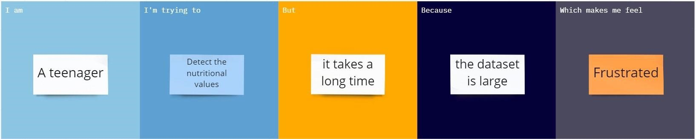

PROBLEM STATEMENT -2 :

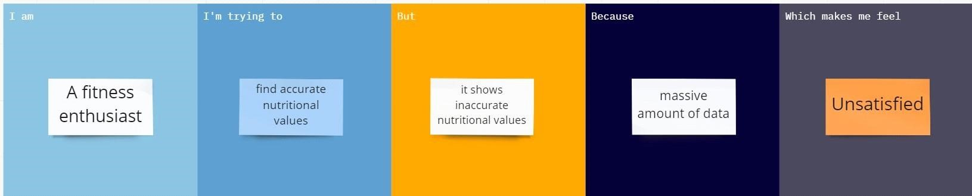

PROBLEM STATEMENT -3:

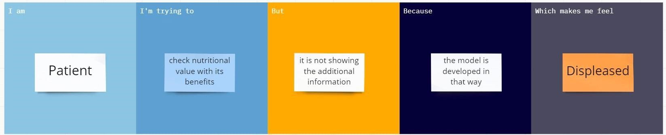

PROBLEM STATEMENT -4 :

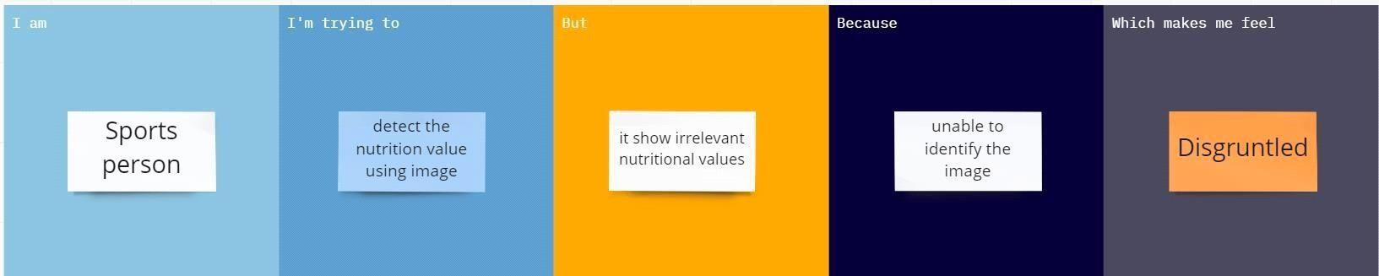

**3.IDEATION AND PROPOSED SOLUTIONS**

#### 3.1 Empathy Map Canvas

Empathy mapping is a simple yet effective [workshop](https://frescopad.com/virtual-workshop-definition/) that can be conducted with a variety of different users in mind, anywhere from stakeholders, individual use cases, or entire teams of people. It can be conducted by many different teams such as design teams, sales, product development or [customer service.](https://www.questionpro.com/blog/customer-service/) Essentially, it is an exercise that seeks to get inside the head of the customer as they interact with your product/service

Nutrition Analyzer does the process of determining the nutritional content of the food that provides information about chemical composition , processing, quality control and containation of food

The following empathy map helped us to understand the customer needs and their expections and to develop our Nutrition Analyser.

##### EMPATHY MAP

#### 3.2 Ideation and Brainstorming

Step-1: Team Gathering, Collaboration and Select the Problem Statement

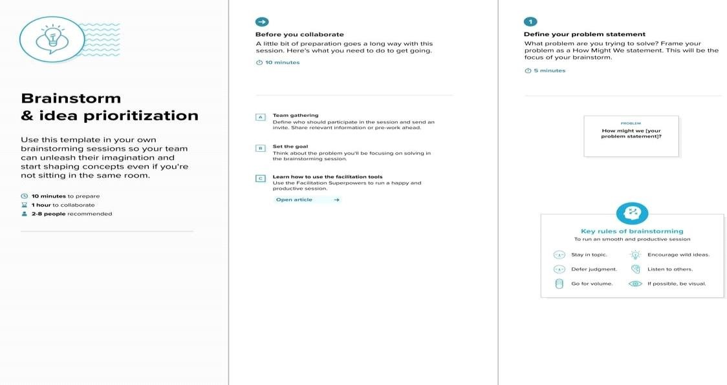

**Step-2: Brainstorm, Idea Listing and Grouping**

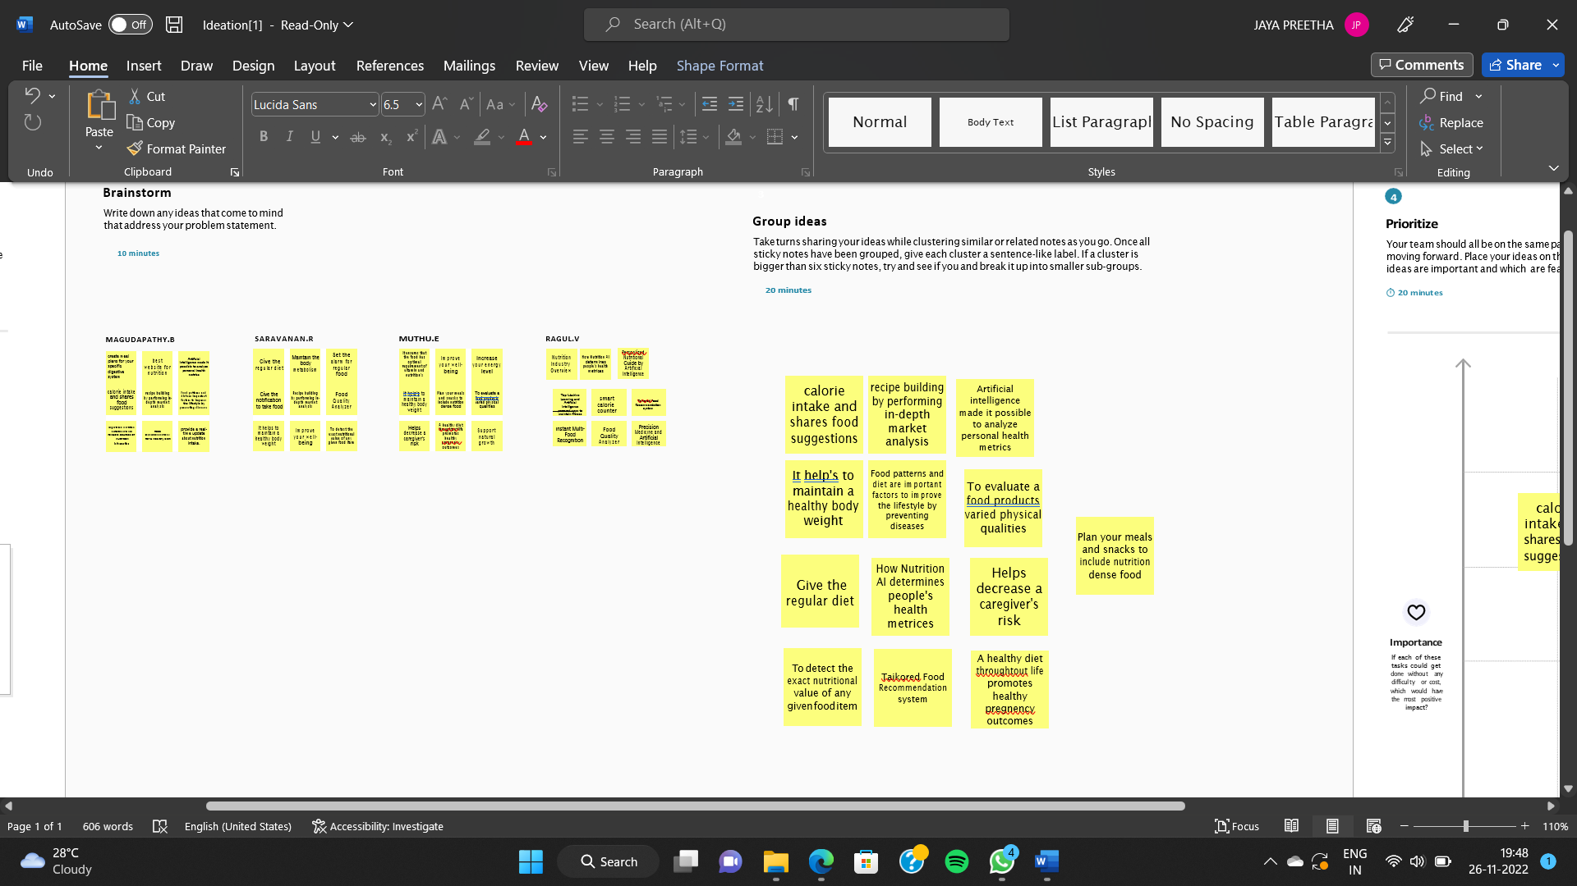

**Step-3: Idea Prioritization**

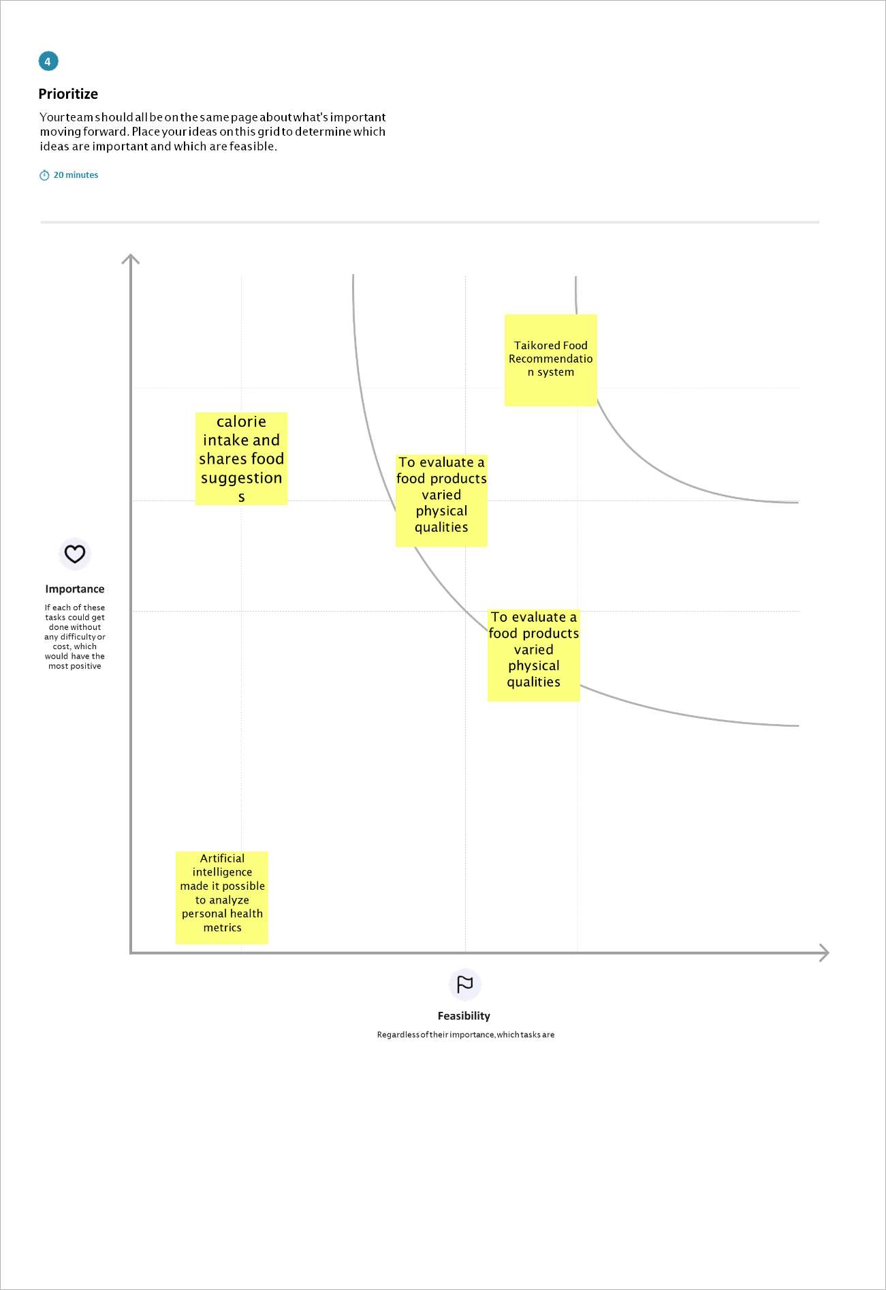

**3.3 Proposed Solution**

|  |  |  |
| --- | --- | --- |
| **S. No** | **Parameter** | **Description** |
| 1. | Problem Statement (problem to be solved) | People are not eating sufficient amounts of food to provide the calories, vitamins and minerals they need optimal health, while in others, people are eating far more food than is necessary for their health. |
| 2. | Idea / Solution description | Food Nutrition Analysis helps in the detailed and perfect determination of the component nutrients present in any food item. |
| 3. | Novelty / Uniqueness | It is web based program that allow anyone to analysis the foods they eat to determine if they are consuming all the different nutrients. |
| 4. | Social Impact / Customer Satisfaction | This review demonstrates that general food quality fundamentally influences customer satisfaction and behaviour intentions. |

|  |  |  |
| --- | --- | --- |
| 5. | Business Model (Revenue Model) | The business model of a fitness app like MyFitnessPal.  Increasing demand for health assessment and rising health consciousness is anticipated to drive market growth in the fitness app market. |
| 6. | Scalability of the Solution | It is well nutrition analysis software for sports clubs, dieticians, gyms and more professionals and firms. |

**3.4 Problem-Solution Fit**

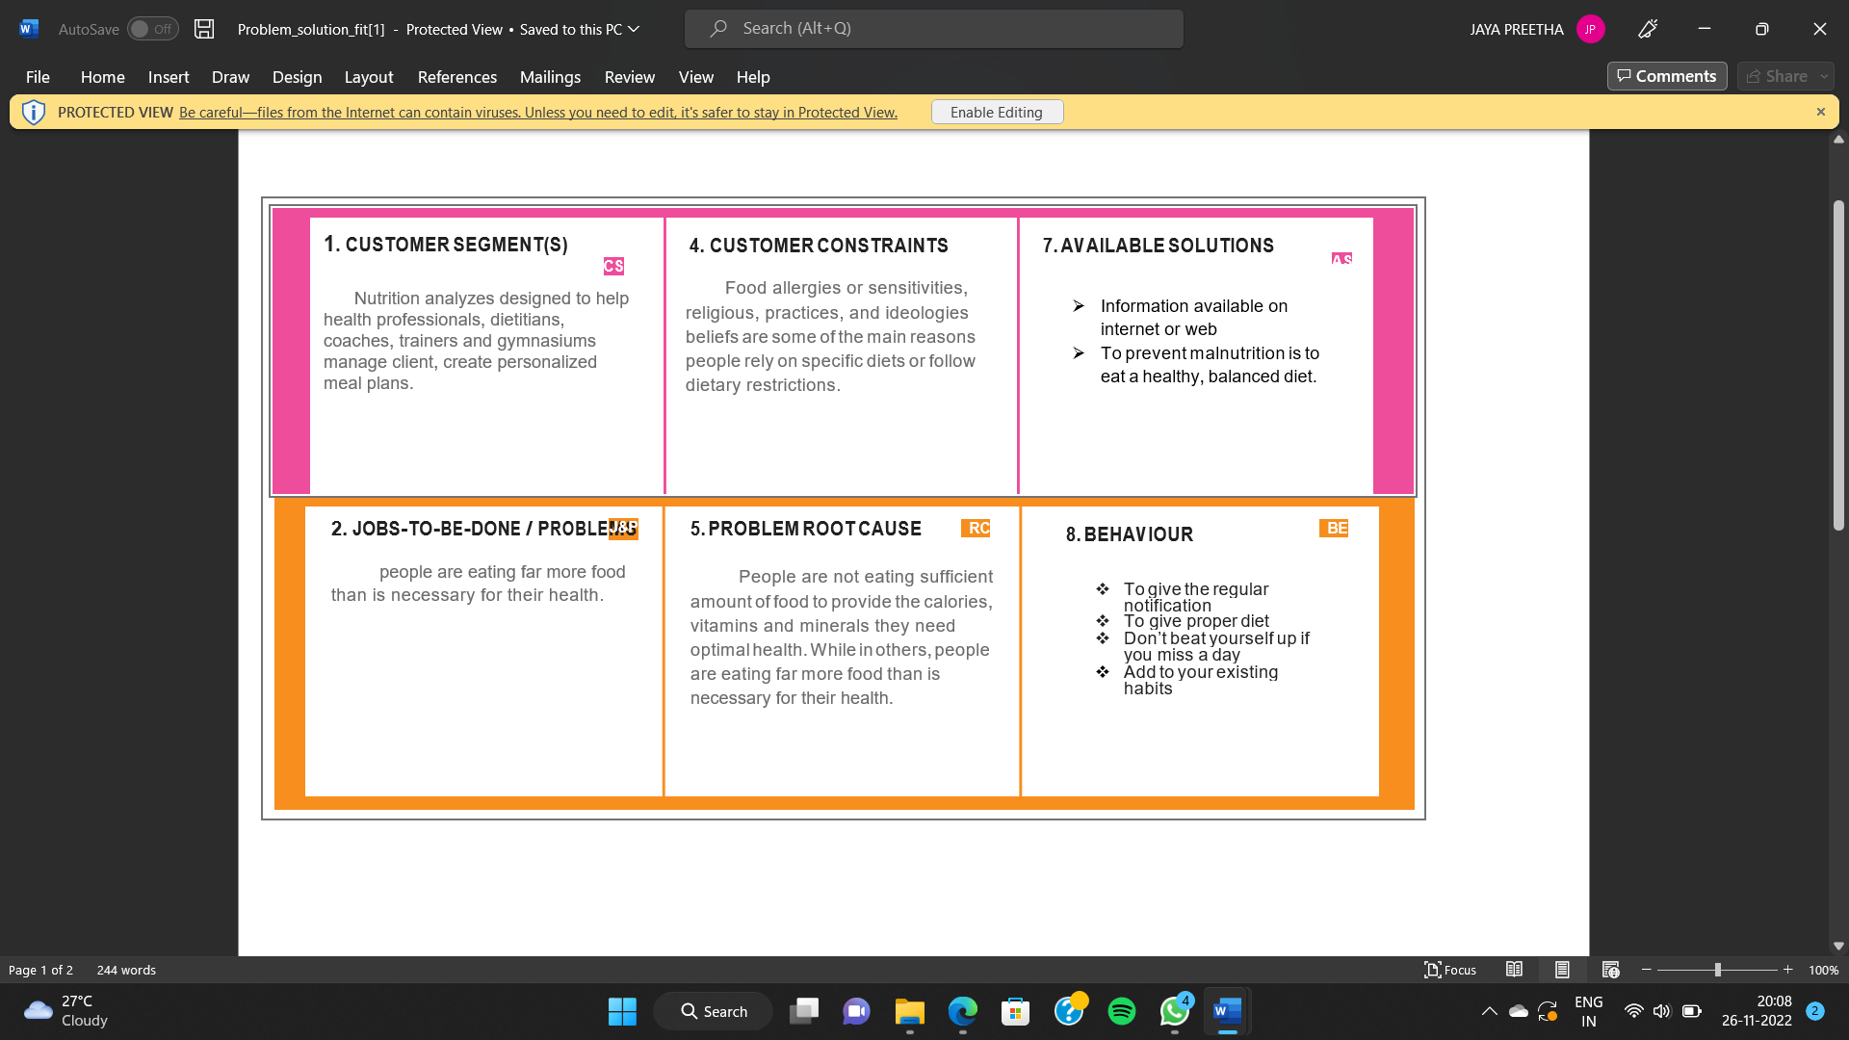

# \4. REQUIREMENT ANALYSIS

## 4.1 Functional Requirements

Following are the functional requirements for the proposed solution

|  |  |  |
| --- | --- | --- |
| FR.NO | FUNCTIONAL REQUIREMENT (EPIC) | SUB REQUIREMENT(STORY/SUB TASK) |
| FR-1 | User Registration | Registration through web application form registration through Gmail. |
| FR-2 | User Confirmation | Confirmation via Email confirmation via OTP. |

## 4.2 Non Functional Requiurements

Following are the functional requirements for the proposed solution.

|  |  |  |
| --- | --- | --- |
| FR.NO | NON-FUNCTIONAL  REQUIREMENTS | DESCIPTION |
| NFR-1 | USABILITY | ➤ No training is required to access the Nutrition Analyzer.  ➤ The results should be loaded within 30 seconds.  ➤ It should be user friendly and comfortable.  ➤ It should be simple and easy to use.  ➤ The results should be self explanatory so that it can be understood by common people. |
| NFR-2 | SECURITY | ➤ AI powered nutrition analyzer for fitness should contain more security in which our data which entered or maintained should be more security.  ➤ With the help of the username and password it provides more security in which it can access more securable and the data are private.  ➤ It should be social-economic which should access to sufficient and safe to use. |
| NFR-3 | RELIABILITY | ➤ It is Important that the AI powered nutrition analyzer for fitness provides should Must reliable.  ➤ How a person can find it is reliable? It is easy to find that is he/she can compare the nutrition based food with other |

|  |  |  |
| --- | --- | --- |
|  |  | nutrition related application so, it can easily rectify whether it is reliable or not.  ➤ But it take too much time, to avoid this a reliable application should made in which it itself produces whether we can get correct solution or not. So, it is necessary that the AI powered nutrition analyzer for fitness should have proper data and information in which we can get a correct information about it and also get a proper guidance about it.  ➤ With the proper guideness and proper information in which we can get a nutrition properly and we can have get a proper fitness plan.  ➤ It should also provides the information on nutrition and health which it should prevent from health information on diseases, health risks and prevention guidelines. It should also provides an extension a research based online learning network with several resource areas, so it provides more reliability in that area. For more reliable it can also contains the calorie information, balanced diet plans, what type food can consumed at what time etc..... So, by this way it can reliable. |
| NFR-4 | PERFORMANCE | ➤ It should provide more number of users to consume at any time and at any place.  ➤ It should provide Reliability, Scalability, Security and Usability.  ➤ It should contain minimum data while over-paging the websites or application and it is necessary that it should not exceed more than 20mb.  ➤ While consuming the page it should provide the response as much as possible without any delay or time traffic. |

|  |  |  |
| --- | --- | --- |
|  |  | ➤ The connection should e properly maintained so that it can use while travelling or in remote places.  ➤ The nutritious food to meet their dietary needs and the food preferences for an active and healthy life.  ➤ It should be consistently access, availability and affordability of foods  ➤ and beverages that promote well-being and prevent from diseases.  ➤ It should suitable in all situations that exists to all people, at all times. |
| NFR-5 | AVAILABILITY | ➤ Easy to access Data.  ➤ Avoids Data redundancy and inconsistency.  ➤ Fast and Efficient. ➤ User Friendly. |
| NFR-6 | SCALABILITY | ➤ The architecture for AI powered Nutrition Analyzer for fitness provides the clear procedure daily consumption of food and helps the user to maintain a healthy diet.  ➤ According to their tracking system implemented in architecture provide the proper mechanism to the every individual of their nutrients intake which can be increased or decreased.The premium amount for analyzer is very much optimum. |

**5. PROJECT DESIGN**

## 5.1 Data flow diagrams

Simplified Data flow:

DFD-1(Login):

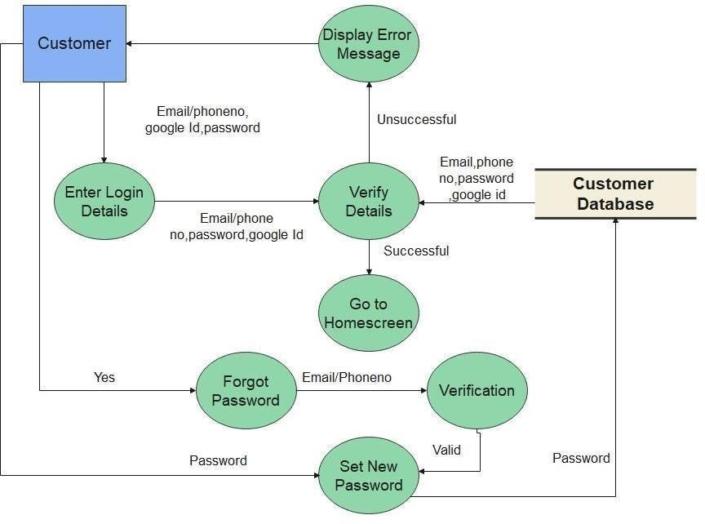

1. The applictaion starts from the user login. the user must enter their mail id and the password to use the nutrition analyzer
2. The next step is user shoud capture the food and upload the food in the specified capture image icon.
3. The third step is click the "Analyze Food" and wait for sometime. The AI database process the image.
4. The tool fuguring out image and page automatically give the information about food such that the quality off the food, Nutrition , then issue the diet and fitness plan for the user.

DFD-1(Registration):

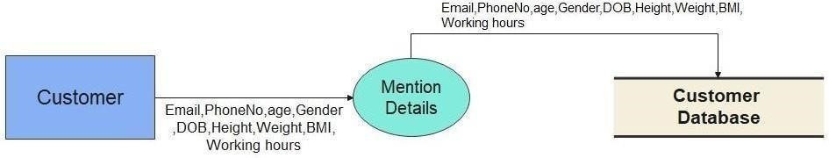

DFD-1(Payment):

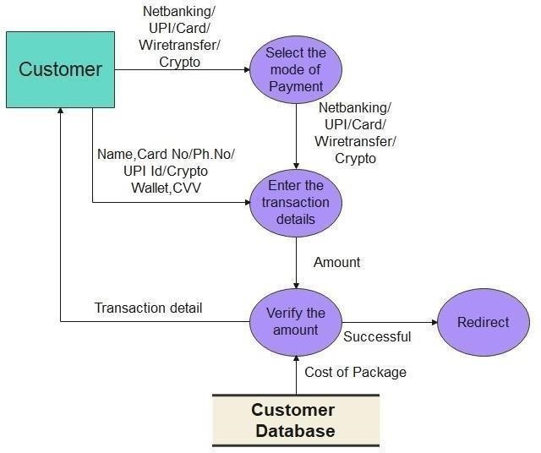

DFD-0:

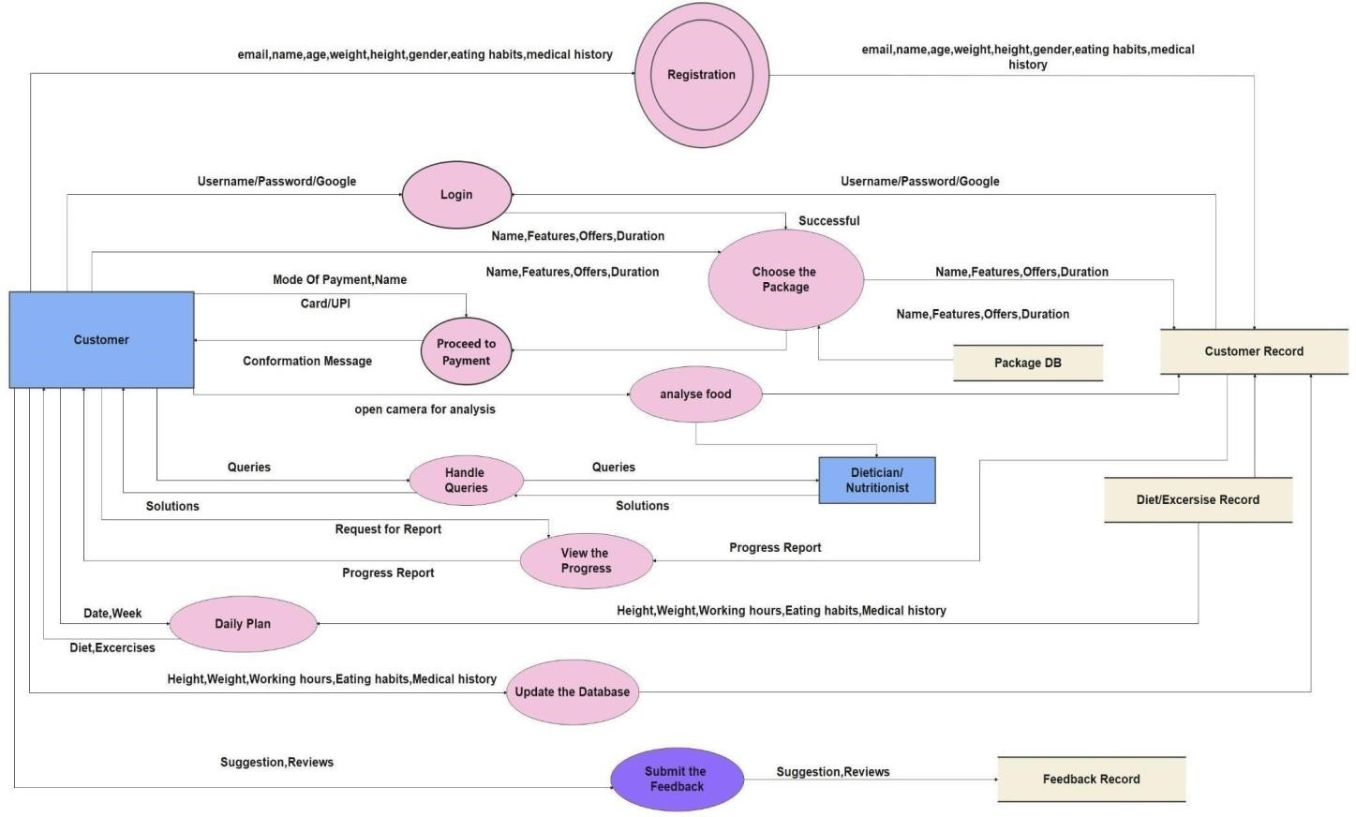

#### 5.2 Technical and Solution Architecture

**Technical Architecture:**

ABSTRACT :

➤ The main aim of the project is to building a model which is used for classifying the fruit, vegetables, spinach, fish, meat, Green leafy vegetables etc….. depends on the different characteristics like colour, shape, texture etc.

➤ Here the user can capture the images of different fruits, vegetables, spinach, Green leafy vegetables, fish, meat , etc.. and then the image will be sent the trained model. The model analyses the image and detect the nutrition based on the fruits like (Sugar, Fibre, Protein, Calories, etc.).

➤ Food is essential for human life and has been the concern of many healthcare conventions. Nowadays new dietary assessment and nutrition analysis tools enable more opportunities to help people understand their daily eating habits, exploring nutrition patterns and maintain a healthy diet.

➤ Nutritional analysis is the process of determining the nutritional content of food. It is a vital part of analytical chemistry that provides information about the chemical composition, processing, quality control and contamination of food.

➤ This solution helps fitness enthusiasts to do Nutritional analysis of food which provides information about the chemical composition, processing, and quality control of food.

➤ The chance of occurrence of error is minimal since the model provides more precise reports of the analysis.

OBJECTIVES:

➤ Being healthy should be an integral component of your life. A Healthy intake of food can assist in the prevention of chronic diseases and long-term ailments.

➤ What you eat is closely related to your health. Eating a healthy diet can help boost your immune systems, help you maintain a healthy weight and can improve your overall health.

➤ The importance of diet can't be overstated for a healthy lifestyle. People get the vitamins, minerals and nutrients they need to function and thrive from the foods they eat, so choosing foods that offer the most of those components helps improve quality of life.

➤ It's just as important to limit foods that are high in fat, sugar, sodium and cholesterol as it is to choose healthy foods.

➤ Nutrition helps in functioning, maintaining, or improving important bio metabolisms like building muscles, producing energy, thriving body cells, improving body health, replenish malnourishment, and strengthening immunity. If food is the reason, Nutrition is the result.

➤ Consumers have become more concerned over the quality and compositions of their food purchases, the contained ingredients, and the presence of additives and contaminants. Therefore, knowledge of the chemical and biochemical composition of foods is important to the health, well-being, and safety of the consumers.

➤ We consume food so that we can obtain proper nutrition. Hence it is very important for us to know the composition of nutrients in our food.

➤ Through a nutrition analyzer we can measure the nutrients and with that information we can make a healthy diet by adding nutrients required for our body and excluding which is not good for health.

### TECHNOLOGY ARCHITECTURE

Table-1 : Components & Technologies:

|  |  |  |  |
| --- | --- | --- | --- |
| **S.No** | **Component** | **Description** | **Technology** |
| 1. | User Interface | How user interacts with application e.g.  Web UI, Mobile App, etc. | HTML, CSS, JavaScript. |
| 2. | Application Logic-1 | Logic for a process in the application | Python |
| 3. | Application Logic-2 | Logic for a process in the application | IBM Watson STT service |
| 4. | Application Logic-3 | Logic for a process in the application | IBM Watson Assistant |
| 5. | Database | Data Type, Configurations etc. | MySQL, NoSQL, etc. |
| 6. | Cloud Database | Database Service on Cloud | IBM Cloudant. |
| 7. | File Storage | File storage requirements | IBM Block Storage or Other  Storage Service or Local Filesystem |
| 8. | External API-1 | Purpose of External API used in the application | Rapid API, etc. |
| 9. | External API-2 | Purpose of External API used in the application | Rapid API, etc. |
| 10. | Machine Learning Model | Purpose of Machine Learning Model | Object Recognition Model, etc. |
| 11. | Infrastructure (Server / Cloud) | Application Deployment on  Local System / Cloud  Local Server Configuration:  Cloud Server Configuration : | Local, Cloud Foundry, Kubernetes, etc. |

Table-2: Application Characteristics:

|  |  |  |  |
| --- | --- | --- | --- |
| **S.No** | **Characteristics** | **Description** | **Technology** |
| 1. | Open-Source Frameworks | List the open-source frameworks used | Technology of  Opensource framework |
| 2. | Security  Implementations | List all the security / access controls implemented, use of firewalls etc. | e.g. SHA-256,  Encryptions, IAM  Controls, OWASP etc. |
| 3. | Scalable  Architecture | Justify the scalability of architecture (3 – tier, Micro-services) | Technology used |
| 4. | Availability | Justify the availability of application (e.g. use of load balancers, distributed servers etc.) | Technology used |

**Solution Architecture:**

Being healthy should be an integral component of your life. A Healthy intake of food can assist in the prevention of chronic diseases and long-term ailments. What you eat is closely related to your health. Eating a healthy diet can help boost your immune systems, help you maintain a healthy weight and can improve your overall health. The importance of diet can't be overstated for a healthy lifestyle. People get the vitamins, minerals and nutrients they need to function and thrive from the foods they eat, so choosing foods that offer the most of those components helps improve quality of life. It's just as important to limit foods that are high in fat, sugar, sodium and cholesterol as it is to choose healthy foods.Nutrition helps in functioning, maintaining, or improving important bio metabolisms like building muscles, producing energy, thriving body cells, improving body health, replenish malnourishment, and strengthening immunity. If food is the reason, Nutrition is the result. Consumers have become more concerned over the quality and compositions of their food purchases, the contained ingredients, and the presence of additives and contaminants. Therefore, knowledge of the chemical and Biochemical composition of foods is important to the health, well-being, and safety of the consumers. We consume food so that we can obtain proper nutrition. Hence it is very important for us to know the composition of nutrients in our food. Through a nutrition analyzer we can measure the nutrients and with that information we can make a healthy diet by adding nutrients required for our body and excluding which is not good for health.

➤ This solution helps fitness enthusiasts to do Nutritional analysis of food which provides information about the chemical composition, processing, and quality control of food.

➤ The chance of occurrence of error is minimal since the model provides more precise reports of the analysis.

➤ First, the user captures the images of the food and uploads it.

➤ Next, the image will be sent to the trained model.

➤ The model will classify the food based on the different characteristics like colou

**DIAGRAM:**

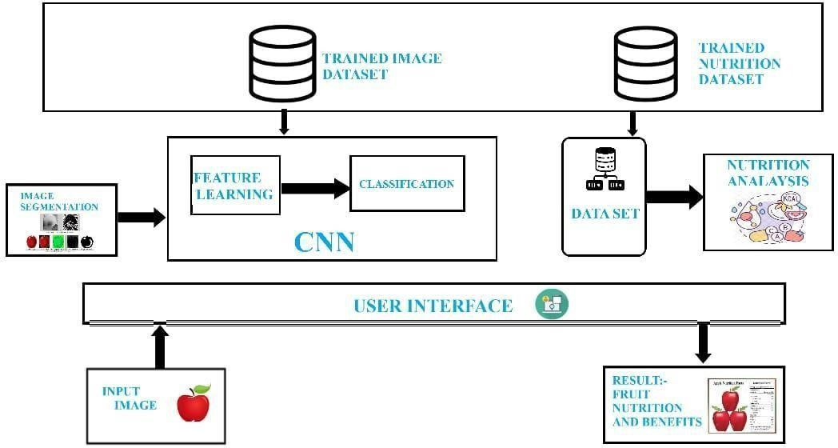

**RELIABILITY:**

|  |  |
| --- | --- |
| □ | It is Important that the AI powered nutrition analyzer for fitness provides should Must reliable. |
| □ | How a person can find it is reliable? It is easy to find that is he/she can compare the nutrition based food with other nutrition related application so, it can easily rectify whether it is reliable or not. |
| □ | But it take too much time, to avoid this a reliable application should made in which it itself produces whether we can get correct solution or not. So, it is necessary that the AI powered nutrition analyzer for fitness should have proper data and information in which we can get a correct information about it and also get a proper guidance about it. |
| □ | With the proper guideness and proper information in which we can get a nutrition properly and we can have get a proper fitness plan. |
| □ | It should also provides the information on nutrition and health which it should prevents from health information on diseases, health risks and prevention guidelines. It should also provides an extension a research based online learning network with several resource areas, so it provides more reliability in that area. For more reliable it can also contains the calorie information, balanced diet plans, what type food can consumed at what time etc..... So, by this way it can reliable. |

**SCALABILITY:**

□ The architecture for AI powered Nutrition Analyzer for fitness provides the clear procedure daily consumption of food and helps the user to maintain a healthy diet.

□ According to their tracking system implemented in architecture provide the proper mechanism to the every individual of their nutrients intake which can be increased or decreased.

□ The premium amount for analyzer is very much optimum.

**PERFORMANCE:**

|  |  |  |
| --- | --- | --- |
| □ | It should provide more number of users to consume at any time and at any place. | |
| □ | It should provide Reliability, Scalability, Security and Usability. | |
| □ | It should contain minimum data while over-paging the websites or application and it is necessary that it should not exceed more than 20mb. | |
| □ | While consuming the page it should provide the response as much as possible without any delay or time traffic. | |
| □ | | The connection should e properly maintained so that it can use while travelling or in remote places. |
| □ | | The nutritious food to meet their dietary needs and the food preferences for an active and healthy life. |
| □ | | It should be consistently access, availability and affordability of foods and beverages that promote well-being and prevent from diseases. |
| □ | | It should suitable in all situations that exists to all people, at all times. |

**SECURITY:**

□ AI powered nutrition analyzer for fitness should contain more security in which our data which entered or maintained should be more security.

□ With the help of the username and password it provides more security in which it can access more securable and the data are private.

□ It should be social-economic which should access to sufficient and safe to use.

**USABILITY:**

|  |  |
| --- | --- |
| □ | No training is required to access the Nutrition Analyzer. |
| □ | The results should be loaded within 30 seconds. |
| □ | It should be user friendly and comfortable. |
| □ | It should be simple and easy to use. |
| □ | The results should be self explanatory so that it can be understood by common people. |

**5.3 User Stories**

|  |  |  |
| --- | --- | --- |
| **Functional Requirement**  **(Epic)** | **User Story**  **Number** | **User Story / Task** |
| **Data Collection &**  **Image Processing** |  |  |
|  | USN-1 | Collect images of different food items organized into subdirectories based on their respective names |
|  | USN-2 | Import and configure the Image data generator library from  Keras |
|  | USN-3 | Apply Image data generator functionality to training set and testing set |
|  | USN-4 | Improving the image data that suppresses unwilling distortions or enhances some image features important for further processing |
| **Model Building &**  **Testing** |  |  |
|  | USN-5 | Importing the model building libraries and Initializing the model |
|  | USN-6 | Adding CNN layers, Dense layers & other necessary layers and Compile the model |
|  | USN-7 | Train & Test the model based on the image dataset |
| **Application building** |  |  |
|  | USN-8 | Create HTML pages to design the front-end part of the web page |
|  | USN-9 | Create the flask application and loading the model file |
|  | USN-10 | Routing to the HTML page and Running the application |
| **Cloud integration** |  |  |
|  | USN-11 | Train the model on Cloud |

**6. PROJECT PLANNING & SCHEDULING**

## 6.1 Sprint Planning & Estimation

Product Backlog, Sprint Schedule, and Estimation

|  |  |  |  |  |  |  |
| --- | --- | --- | --- | --- | --- | --- |
| **Sprint** | **Functional**  **Requirement**  **(Epic)** | **User**  **Story**  **Numbe**  **r** | **User Story / Task** | **Story Points** | **Priority** | **Team Memb**  **ers** |
| Sprint-1 | Data  Collection | USN-  1 | Dataset - Collecting images of food items apples , banana, orange, pineapple, watermelon for analysis | 5 | High | Magudapathy.B |
| Sprint-1 | Image  Preprocessing | USN-  2 | Image data augmentation - Increasing the amount of data by generating new data points from existing data | 4 | Medium | Saravanan.R |
| Sprint-1 | USN-  3 | Image Data Generator Class - Used for  getting the input of the original data | 4 | Medium | Muthu.E |
| Sprint-1 | USN  -4 | Applying image data generator functionality to train set and test set | 4 | Medium | Ragul.V |
| Sprint-2 | Modeling  Phase | USN  -5 | Defining the model architecture - Building the model using deep learning approach and adding CNN layers | 4 | High | Magudapathy.B |
| Sprint-2 | USN  -6 | Training , saving, testing and predicting the model | 5 | High | Saravanan.R |
| Sprint-2 | USN-  7 | Database creation for the input classes | 4 | High | Muthu.E |

## 6.2 Sprint Delivery Schedule

|  |  |  |  |  |  |  |
| --- | --- | --- | --- | --- | --- | --- |
| **Sprint** | **Functional Requiremen**  **t (Epic)** | **User**  **Story**  **Number** | **User Story / Task** | **Story Point s** | **Priority** | **Team Membe**  **rs** |
| Sprint- 2 | Development phase | USN- 8 | User database creation - It contains the details of users | 3 | Medium | Ragul.V |
| Sprint-2 | USN- 9 | Home page creation - It shows options of the application | 2 | Low | Saravanan.R |
| Sprint-2 | USN-  10 | Login and registration page creation -  User can register and login through gmail with Id and password | 2 | Low | Magudapathy.B |
| Sprint-3 | USN- 11 | Dashboard creation – Dashboard contains  the information of user profile and features of the application | 2 | Low | Muthu.E |
| Sprint-3 | USN- 12 | User Input Page Creation - It is for the user to feed the input images | 4 | Medium | Ragul.V |
| Sprint-3 | USN- 13 | Analysis and prediction page creation - It shows the prediction of given user input | 4 | Medium | Magudapathy.B |
| Sprint-3 | USN-  14 | Creation of about us , feedback and rating page – It shows application history and feedback page to users | 4 | Medium | Saravanan.R |
| Sprint-3 | Application  Phase | USN-  15 | Building the python code and importing the flask module into the  Project | 6 | High | Muthu.E |
| Sprint-4 | USN-  16 | Create the Flask application and loading the model | 5 | High | Ragul.V |
| Sprint-4 | USN-  17 | API integration - Connecting front end and back end and perform routing and run the application | 5 | High | Magudapathy.B |
| Sprint-4 | Deployment Phase | USN-  18 | Cloud deployment – Deployment of application by using IBM cloud | 4 | High | Saravanan.R |

Project Tracker, Velocity & Burn down Chart:

|  |  |  |  |  |  |  |
| --- | --- | --- | --- | --- | --- | --- |
| **Sprint** | **Functional**  **Requirement (Epic)** | **User Story Number** | **User Story / Task** | **Story Points** | **Priority** | **Team**  **Members** |
| Sprint-4 | Testing Phase | USN-19 | Functional testing – Checking usability and accessibility | 3 | Medium | Muthu.E |
| USN-20 | Non Functional testing – Checking scalability and performance of the application | 3 | Medium | Ragul.V |

|  |  |  |  |  |  |  |
| --- | --- | --- | --- | --- | --- | --- |
| **Sprint** | **Total**  **Story Point s** | **Duration** | **Sprint Start Date** | **Sprint**  **End Date**  **(Planned)** | **Story Points Completed**  **(as on Planned End**  **Date)** | **Sprint**  **Release**  **Date**  **(Actual)** |
| Sprint-1 | 08 | 5 Days | 29 Oct 2022 | 02 Nov 2022 | 20 | 3 Nov 2022 |
| Sprint-2 | 15 | 5 Days | 03 Oct 2022 | 07 Nov 2022 | 20 | 8 Nov 2022 |
| Sprint-3 | 15 | 5 Days | 08 Nov 2022 | 12 Nov 2022 | 20 | 11 Nov 2022 |
| Sprint-4 | 25 | 5 Days | 13 Nov 2022 | 17 Nov 2022 | 20 | 16 Nov 2022 |

**Velocity:**

Average Velocity= 12/4 =3

#### 6.3 Reports from JIRA

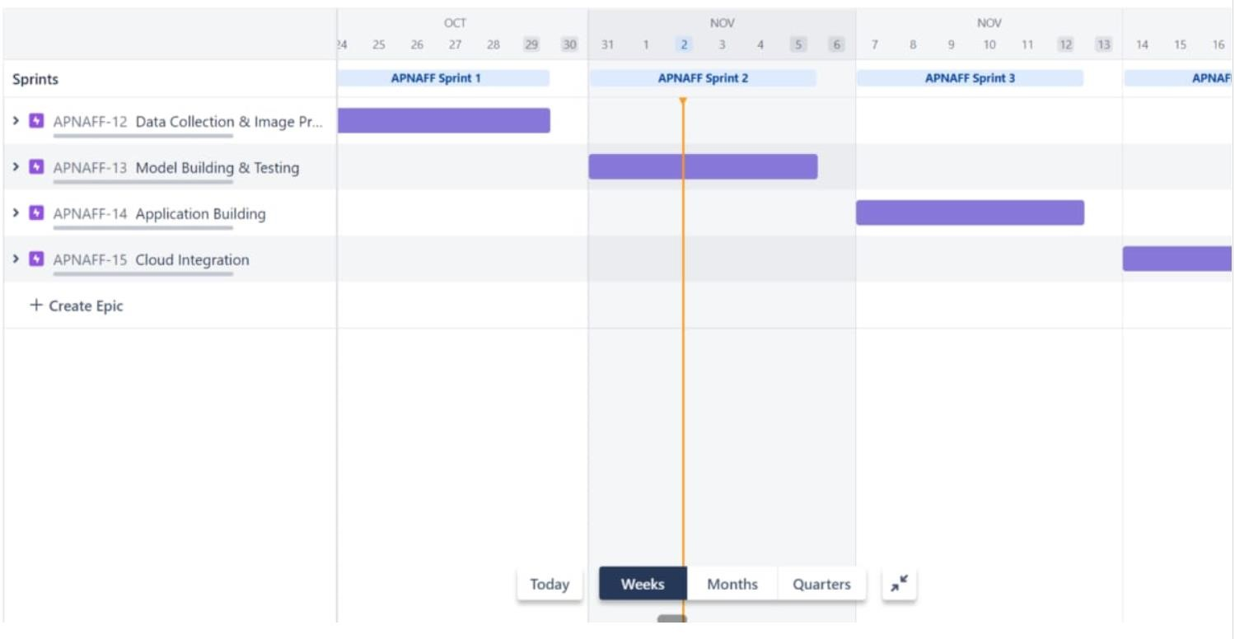

**7. CODING & SOLUTIONING**

#### 7.1.Feature 1

* AI-powered Nutrition Analyzer for Fitness Enthusiasts
* The main aim of the project is to building a model which is used for classifying the fruit depends on the different characteristics like colour, shape, texture etc. Here the user can capture the images of different fruits and then the image will be sent the trained model. The model analyses the image and detect the nutrition based on the fruits like (Sugar, Fibre, Protein, Calories, etc.).
* Languages : Python
* Tools/IDE : Google collaboratory , Spyder
* Libraries : Recommendation

from flask import Flask,render_template,request

# Flask-It is our framework which we are going to use to run/serve our application.

#request-for accessing file which was uploaded by the user on our application. import os import numpy as np #used for numerical analysis from tensorflow.keras.models import load_model#to load our trained model from tensorflow.keras.preprocessing import image import requests app = Flask(__name__,template_folder="templates") # initializing a flask app

# Loading the model model=load_model('nutrition.h5') print("Loaded model from disk")

@app.route('/')# route to display the home page def home():

return render_template('home.html')

@app.route('/image1',methods=['GET','POST'])# routes to the index html def image1():

return render_template("image.html")

@app.route('/predict',methods=['GET', 'POST'])# route to show the predictions in a web UI def launches(): if request.methods=='POST':

f=request.files['file'] #requesting the file basepath=os.path.dirname('__file__')#storing the file directory filepath=os.path.join(basepath,"uploads",f.filename)#storing the file in uploads folder f.save(filepath)#saving the file img=image.load_img(filepath,target_size=(64,64)) #load and reshaping the image x=image.img_to_array(img)#converting image to an array x=np.expand_dims(x,axis=0)#changing the dimensions of the image pred=np.argmax(model.predict(x), axis=1) print("prediction",pred)#printing the prediction

index=['APPLES','BANANA','ORANGE','PINEAPPLE','WATERMELON'] result=str(index[pred[0]]) x=result print(x) result=nutrition(result) print(result) return render_template("0.html",showcase=(result)) import http.client conn = http.client.HTTPSConnection("calorieninjas.p.rapidapi.com") headers = {

'X-RapidAPI-Key': "e5805fbf62mshf8d7308c0600c2dp197087jsn93407e3cce35", 'X-RapidAPI-Host': "calorieninjas.p.rapidapi.com"

}

conn.request("GET", "/v1/nutrition?query=Pineapple", headers=headers) res = conn.getresponse() data = res.read() print(data.decode("utf-8")) import requests url = "https://calorieninjas.p.rapidapi.com/v1/nutrition" querystring = {"query":"Pineapple"} headers = {

"X-RapidAPI-Key": "e5805fbf62mshf8d7308c0600c2dp197087jsn93407e3cce35", "X-RapidAPI-Host": "calorieninjas.p.rapidapi.com"

}

response = requests.request("GET", url, headers=headers, params=querystring print(response.text) if __name__ == "__main__": # running the app app.run(debug=False)

#### 7.1.Feature 2

**home.html**

<!DOCTYPE

html>

<html>

<head>

<meta charset="UTF-8">

<meta name="viewport" content="width=device-width, initial-scale=1.0">

<meta http-equiv="X-UA-Compatible" content="ie=edge">

<title>Home</title>

<link href="https://cdn.bootcss.com/bootstrap/4.0.0/css/bootstrap.min.css" rel="stylesheet">

<script src="https://cdn.bootcss.com/popper.js/1.12.9/umd/popper.min.js">

</script>

<script src="https://cdn.bootcss.com/jquery/3.3.1/jquery.min.js"></script>

<script src="https://cdn.bootcss.com/bootstrap/4.0.0/js/bootstrap.min.js"></script>

<link href="{{ url_for('static', filename='css/main.css') }}" rel="stylesheet">

<style> body

{

background-image: url("https://img.freepik.com/free-photo/top-view-healthy-balanced-vegetarian-food_1150-370 background-size: cover;

background-repeat: no-repeat; background-attachment: fixed; background-size: 100% 100% ;

}

.bar

{

margin: 0px; padding:5px; background-color: #c0df84; color:black; font-family:'Roboto',sans-serif; font-style: italic; border-radius:20px; font-size:25px; text-align:center; width: 400px;

} h3

{

margin: 0px; padding:5px; background-color:#c0df84; width: 400px; color:#00000; font-family:'Roboto',sans-serif; font-style: italic; border-radius:20px; font-size:15px;

} a

{

color:#c0df84; float:center; text-decoration:none; font-style:normal; padding-right:20px;

}

a:hover{

background-color:black; color:white; border-radius:15px;0 font-size:30px; padding-left:10px;

}

.div1{ background-color: lightgrey; width: 500px; border: 10px solid peach; padding: 20px; margin: 20px; height: 500px;

}

.header {position: relative;

top:0;

margin:0px; z-index: 1; left: 0px; right: 0px; position: fixed; background-color: #8B008B ; color: white;

box-shadow: 0px 8px 4px grey; overflow: hidden; padding-left:20px; font-family: 'Josefin Sans' font-size: 2px; width: 100%; height:8%;

text-align: center;

}

.topnav {

overflow: hidden; background-color: #FCAD98;

}

.topnav-right a {

float: left; color: black; text-align: center; padding: 14px 16px; text-decoration: none;

font-size: 10px;

}

.topnav-right a:hover { background-color: #FF69B4; color: black;

}

.topnav-right a.active { background-color: #DA70D6; color: black;

}

.topnav-right { float: right; padding-right:100px;

}

</style>

</head>

<body>

<!--Brian Tracy-->

<div class="header">

<div style="width:50%;float:left;font-size:2vw;text-align:left;color:black; padding-top:1%; padding-left:5%;">Nutrtion Image Analysis</div>

<div class="topnav-right"style="padding-top:0.5%;">

<a class="active" href="{{ url_for('home')}}">Home</a>

<a href="{{ url_for('image1')}}">Classify</a>

</div>

</div>

</div>

<br>

<br>

<br>

<br>

<br>

<br>

<br>

<br>

<h1>

<center>

<h3>Food is essential for human life and has been the concern of many healthcare conventions. Nowadays new dietary assessment and nutrition analysis tools enable more opportunities to help people understand their daily eating habits, exploring nutrition patterns and maintain a healthy diet.Nutritional analysis is the process of determining the nutritional content of food. It is a vital part of analytical chemistry that provides information about the chemical composition, processing, quality control and contamination of food. It ensures compliance with trade and food laws.</h3>

</center>

</h1>

</body>

</html>

#### image.html

<div style="float:left">

<br>

<br>

<h5><font color="black" size="3" font-family="sans-serif">

<b>Upload image to classify</b></font></h5><br><br>

<div>

<form id="upload-file" method="post" enctype="multipart/form-data">

<label for="imageUpload" class="upload-label">

Choose...

</label>

<input type="file" name="file" id="imageUpload" accept=".png, .jpg, .jpeg">

</form>

<center> <div class="image-section" style="display:none;">

<div class="img-preview">

<div id="imagePreview">

</div></center>

</div>

<center><div>

<button type="button" class="btn btn-primary btn-lg " id="btn-predict">Classify</button>

</center></div>

</div>

<div class="loader" style="display:none;margin-left: 450px;"></div>

<h3 id="result">

<span><p style="padding-top: 25px;"><h4>Food Classified is : <h4><b><u>{{showcase}}{{showcase1} </h3>

</div>

</div>

#### ImagePrediction.html

!DOCTYPE html>

<html>

<head>

<meta charset="UTF-8">

<meta name="viewport" content="width=device-width, initial-scale=1.0">

<meta http-equiv="X-UA-Compatible" content="ie=edge">

<title>Predict</title>

<link href="https://cdn.bootcss.com/bootstrap/4.0.0/css/bootstrap.min.css" rel="stylesheet">

<script src="https://cdn.bootcss.com/popper.js/1.12.9/umd/popper.min.js"> </script>

<script src="https://cdn.bootcss.com/jquery/3.3.1/jquery.min.js"></script>

<script src="https://cdn.bootcss.com/bootstrap/4.0.0/js/bootstrap.min.js"> </script>

<link href="{{ url_for('static', filename='css/main.css') }}" rel="stylesheet">

<style> body

{

background-image: url("https://i.pinimg.com/originals/be/21/1a

/be211ad5043a8d05757a3538bdd8f450.jpg"); background-size: cover;

}

.bar

{

margin: 0px; padding:20px; background-color:white; opacity:0.6; color:black; font-family:'Roboto',sans-serif; font-style: italic; border-radius:20px; font-size:15px;

} a

{

color:grey; float:right; text-decoration:none; font-style:normal; padding-right:20px;

}

a:hover{ background-color:black; color:white; border-radius:15px;0 font-size:30px; padding-left:10px;

}

.div1{

background-color: lightgrey; width: 500px; border: 10px solid peach; padding: 20px; margin: 20px; height: 500px;

}

.header { position: relative;

top:0;

margin:0px; z-index: 1; left: 0px; right: 0px; position: fixed; background-color: #8B008B ;

color: white;

box-shadow: 0px 8px 4px grey; overflow: hidden; padding-left:20px;

font-family: 'Josefin Sans'; font-size: 2vw; width: 100%; height:8%;

text-align: center;

}

.topnav {

overflow: hidden; background-color: #FCAD98;

}

.topnav-right a { float: left; color: black; text-align: center; padding: 14px 16px; text-decoration: none; font-size: 18px;

}

.topnav-right a:hover { background-color: #FF69B4; color: black;

}

.topnav-right a.active { background-color: #DA70D6; color: black;

}

.topnav-right { float: right; padding-right:100px;

}

</style>

</head>

<body>

<div class="header">

<div style="width:50%;float:left;font-size:2vw;text-align:left;color:black; padding-top:1%;padding-left:5%;">Nutrtion

<div class="topnav-right"style="padding-top:0.5%;">

<a href="{{ url_for('home')}}">Home</a>

<a class="active" href="{{ url_for('image1')}}">Classify</a>

</div>

</div>

<br>

</div>

<div class="container">

<center>

<div id="content" style="margin-top:2em"></div></center>

</div>

</body>

<footer>

<script src="{{ url_for('static', filename='js/main.js') }}" type="text/javascript"></script>

</footer>

</html>

#### 0.html

<html lang="en" dir="ltr">

<head>

<style>

</style>

<meta charset="utf-8">

<title>Nutrition Image Analysis</title>

<link rel="shortcut icon" href="{{ url_for('static', filename='diabetes-favicon.ico') }}">

<link rel="stylesheet" type="text/css" href="{{ url_for('static', filename='style.css') }}">

<script src="https://kit.fontawesome.com/5f3f547070.js" crossorigin="anonymous"></script>

<link href="https://fonts.googleapis.com/css2?family= Pacifico&display=swap" rel="stylesheet">

</head>

<!-- Result -->

<div class="results">

<p style="padding-top: 150px; color:blue;"><h4 style="color:blue;">Food Classified is: <h4><b><h4 style="color:red;"><u>{{showcase1}}<h4><br><h4

style="color:red;"><u>{{showcase}}<h4></p>

</div></div>

</body>

</html>

|  |  |
| --- | --- |
| **8. TESTING** | import numpy as np from tensorflow.keras.models import load_model from tensorflow.keras.preprocessing import image model=load_model('train.h5') model=load_model('dataset.h5') model=load_model('nutrition.h5') img=image.load_img(r"/content/drive/MyDrive |

/CNN/Dataset/TEST_SET/PINEAPPLE/125_100.jpg") img

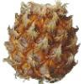

img=image.load_img(r"/content/drive/MyDrive /CNN/Dataset/TEST_SET/PINEAPPLE/125_100.jpg", target_size=(64,64)) img

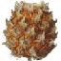

x=image.img_to_array(img) x array([[[[255., 255., 255.], [255., 255., 255.],

[255., 255., 255.],

...,

[255., 255., 255.],

[255., 255., 255.],

[255., 255., 255.]],

[[255., 255., 255.],

[255., 255., 255.],

[255., 255., 255.],

...,

[255., 255., 255.],

[255., 255., 255.],

[255., 255., 255.]],

[[255., 255., 255.],

[255., 255., 255.],

[255., 255., 255.],

...,

[255., 255., 255.],

[255., 255., 255.],

[255., 255., 255.]],

...,

[[255., 255., 255.], [255., 255., 255.],

[255., 255., 255.],

...,

[255., 255., 255.],

[255., 255., 255.],

[255., 255., 255.]],

[[255., 255., 255.],

[255., 255., 255.],

[255., 255., 255.],

...,

[255., 255., 255.],

[255., 255., 255.],

[255., 255., 255.]],

[[255., 255., 255.],

[255., 255., 255.],

[255., 255., 255.],

...,

[255., 255., 255.],

[255., 255., 255.],

[255., 255., 255.]]]], dtype=float32) x=np.expand_dims(x,axis=0)

[[255., 255., 255.],

[255., 255., 255.],

[255., 255., 255.],

...,

[255., 255., 255.],

[255., 255., 255.],

[255., 255., 255.]],

[[255., 255., 255.],

[255., 255., 255.],

[255., 255., 255.],

...,

[255., 255., 255.],

[255., 255., 255.],

[255., 255., 255.]],

[[255., 255., 255.],

[255., 255., 255.],

[255., 255., 255.],

...,

[255., 255., 255.],

[255., 255., 255.],

[255., 255., 255.]]], dtype=float32) pred = model.predict pred array

([[0.25227112, 0.17414774, 0.15219809, 0.20493415, 0.21644896],

[0.26760292, 0.1759095 , 0.15206912, 0.19424875, 0.21016978],

[0.26474723, 0.165203 , 0.14452063, 0.20434381, 0.2211853 ],

...,

[0.24550524, 0.1721549 , 0.16282505, 0.21065485, 0.20885986],

[0.25395462, 0.1735253 , 0.16055605, 0.20655352, 0.20541045], [0.24495909, 0.15889102, 0.16927534, 0.20705006, 0.21982446]], dtype=float32

<bound method Model.predict of <keras.engine. sequential.Sequential object at 0x7f94abfd7c10>> predict_x=model.predict(x_test)

classes_x=np.argmax(predict_x,axis=1) classes_x

array([0, 0, 0, ..., 0, 0, 0]) x_test.class_indices

index=['APPLE','BANANA','ORANGE','WATERMELON','PINEAPPLE'] result=str(index[classes_x[0]]) result

'Pineapple'

#### 8.1 TEST CASES

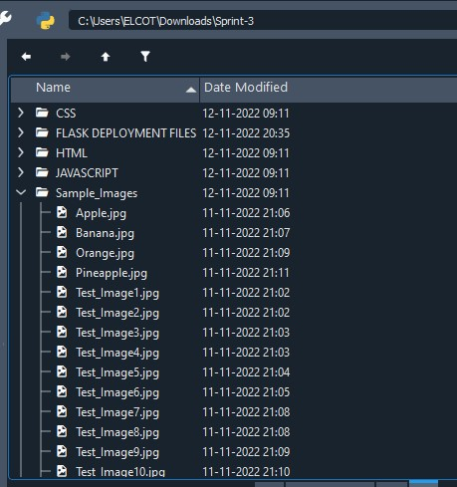

##### 8.2 USER ACCEPTANCE TESTING

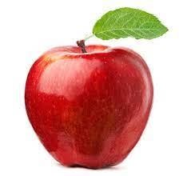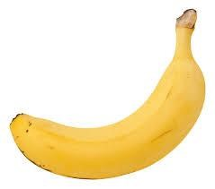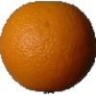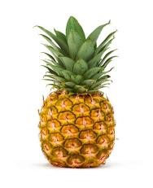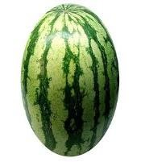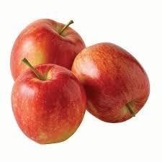

**APPLE BANANA ORANGE PINEAPPLE WATERMELON TEST_IMAGE1**

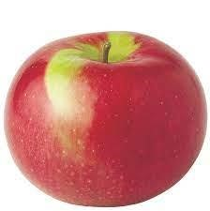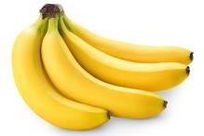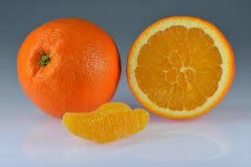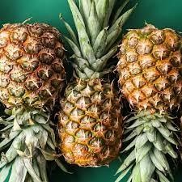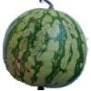

**TEST_IMAGE2 TEST_IMAGE3 TEST_IMAGE4 TEST_IMAGE5 TEST_IMAGE6**

**PERFORMANCE TESTING:**

Epoch 1/10

110/110 [==============================] - 27s 242ms/step - loss: 0.4205 - accuracy: 0.8861 - val_loss: 48.9065 - val_accuracy: 0.1488

Epoch 2/10

110/110 [==============================] - 27s 245ms/step - loss: 0.0082 - accuracy: 0.9989 - val_loss: 62.1670 - val_accuracy: 0.1280

Epoch 3/10

110/110 [==============================] - 28s 255ms/step - loss: 0.0014 - accuracy: 1.0000 - val_loss: 66.6759 - val_accuracy: 0.1488

Epoch 4/10

110/110 [==============================] - 27s 242ms/step - loss: 3.3364e-04 - accuracy:

1.0000 - val_loss: 70.6794 - val_accuracy: 0.1488

Epoch 5/10

110/110 [==============================] - 27s 248ms/step - loss: 1.9990e-04 - accuracy:

1.0000 - val_loss: 74.1865 - val_accuracy: 0.1488

Epoch 6/10

110/110 [==============================] - 26s 236ms/step - loss: 4.5090e-04 - accuracy:

1.0000 - val_loss: 75.5190 - val_accuracy: 0.1308

Epoch 7/10

110/110 [==============================] - 27s 248ms/step - loss: 1.0600e-04 - accuracy:

1.0000 - val_loss: 78.4789 - val_accuracy: 0.1488

Epoch 8/10

110/110 [==============================] - 26s 237ms/step - loss: 7.9529e-05 - accuracy:

1.0000 - val_loss: 80.7918 - val_accuracy: 0.1403

Epoch 9/10

110/110 [==============================] - 26s 236ms/step - loss: 9.2201e-05 - accuracy:

1.0000 - val_loss: 80.3610 - val_accuracy: 0.1431

Epoch 10/10

110/110 [==============================] - 29s 266ms/step - loss: 9.1324e-05 - accuracy:

1.0000 - val_loss: 83.0943 - val_accuracy: 0.1393

<keras.callbacks.History at 0x7fbcb5cb4b10>

**9.RESULTS:**

9.1 Performance Metrics

Output link : https://github.com/IBM-EPBL/IBM-Project-2034-

1658423887/blob/main/Project%20Development%20Phase/Sprint-

3/Output%20Screenshots/Output%20Screenshots.docx

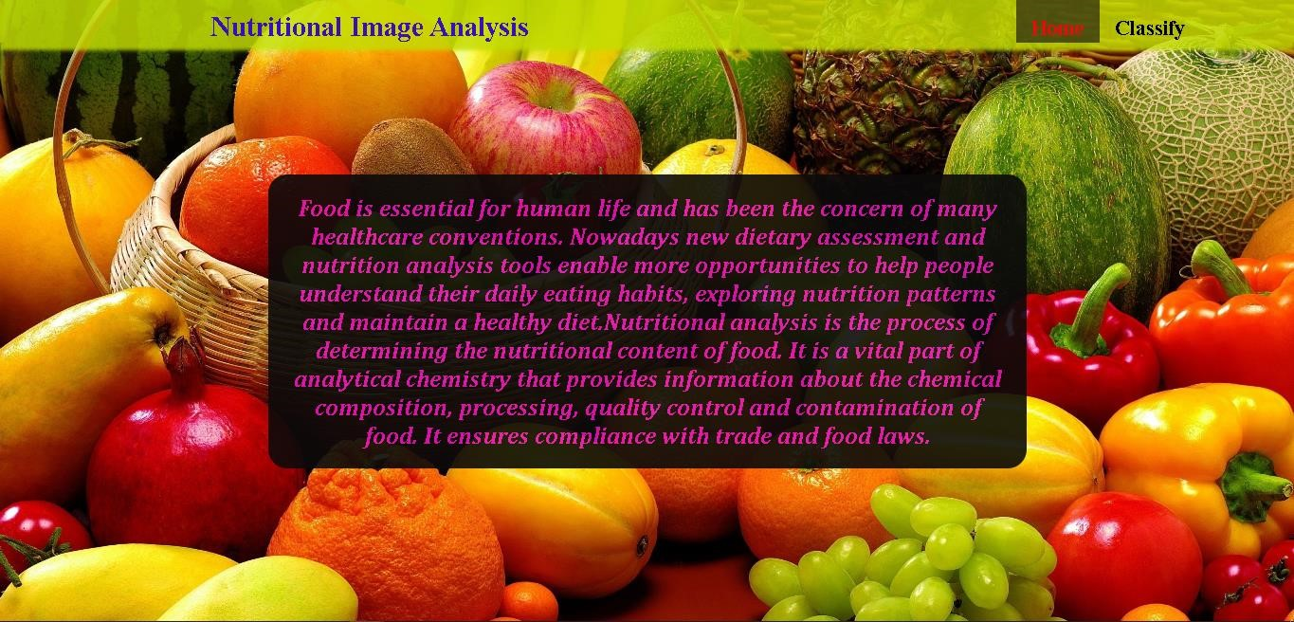

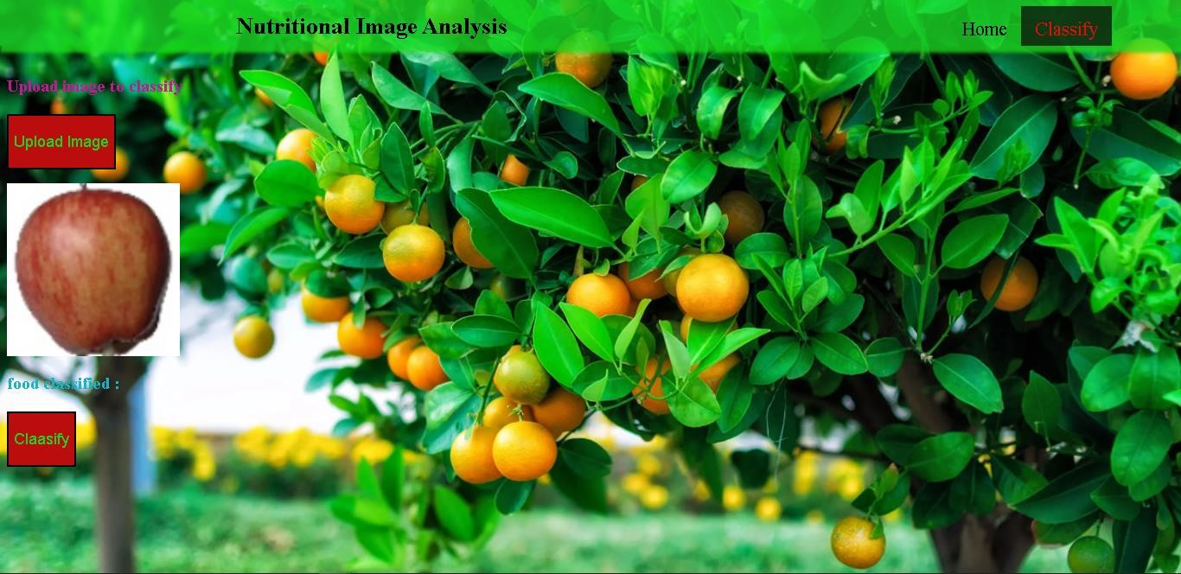

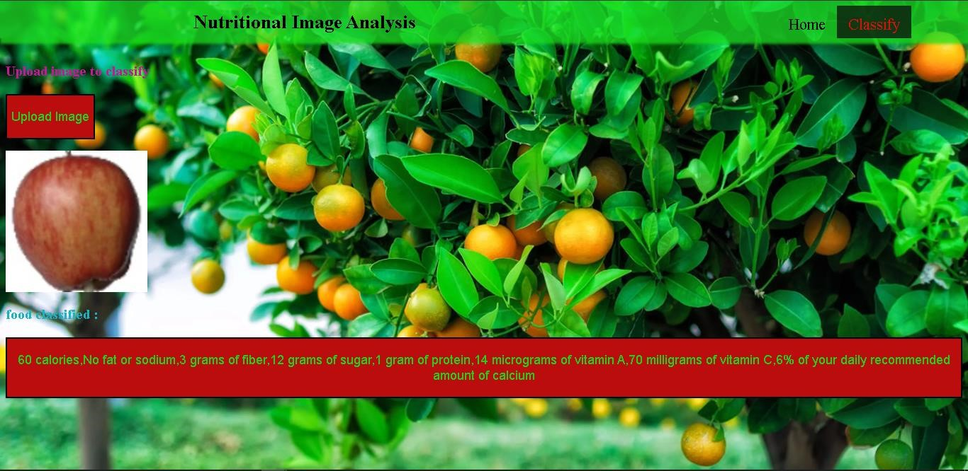

**10. ADVANTAGES AND DISADVANTAGES**

**Advantages:**

➤ Food and food habits are ever-changing and evolving. People and professionals need to quickly adapt to new food products, diets, and changing preferences. The best way to instantly adapt to these changes is to have software that changes and adapts with you.

➤ Using automated nutrition analysis software will allow you to free up more time to innovate or grow your business. If you find a nutrition analysis software that has all the features you need, you can create much more time to focus on improving your business.

➤ Features such as a quick preview of nutrients while adding foods to diets, menus, and recipes give you the ability to save time when new recipes and food products are introduced.

➤ Having quick and easy software to help them plan their meals will save you tons of time.

**Disadvantages:**

➤ This methodology is still limited by its dependency on time-consuming and error-prone manual video annotations, with many studies resorting to the use of multiple human annotators.

➤ Often suffers from reliability issues.

➤ It is extremely expensive due to semantics analysis model and nutritional analysis model.

➤ In order to make recommendations, the system needs to collect nutritional needs from users. Most of the information is only provided through continuous interactions with users. However, in reality, recording nutritional intake from users cannot avoid faults because users usually forget or give wrong information about the foods they have consumed.

➤ Moreover deep learning requires expensive GUIs and hundreds of machines. This increases the cost to the users.

**11.CONCLUSION**

Food is essential for human life and has been the concern of many health care conventions. In this project we have built a nutrition analysis model that classifies the nutritional content of the food through the image uploaded by the user. Such Nutritional analysis helps people understand their daily eating habits, exploring nutrition patterns and maintaining a healthy diet. It is a vital part of analytical chemistry that provides information about the chemical composition, processing, quality control and contamination of food.

The nutritional analysis model is implemented using Convolutional neural network and the web application is built and implemented using Flask framework. As for the future work, the model can be trained and tested on more datasets to provide accurate results and better performance.

**12.FUTURE SCOPE**

The future scope of this project is very brod. Few of them are:

* + The model could be trained using vast database in order to increase the accuracy of results.
  + The Backend framework of the web application can be improved so that the uploaded images can be handled appropriately.
  + In addition to the nutrition analysis, the application can also be designed to provide recipes that can be prepared using the nutrient-rich foods
  + A database can also be implemented for the system so that users can save their data and relook into it later.
  + The Web application can be further developed and launched as an Android App so that anyone anywhere with or without internet connection can access it and get benefited from its use cases.

**13.APPENDIX**

Source Code:

from flask import Flask,render_template,request

# Flask-It is our framework which we are going to use to run/serve our application.

#request-for accessing file which was uploaded by the user on our application.

import os import numpy as np #used for numerical analysis from tensorflow.keras.models import load_model#to load our trained model from tensorflow.keras.preprocessing import image import requests app = Flask(__name__,template_folder="templates") # initializing a flask app

# Loading the model model=load_model('nutrition.h5') print("Loaded model from disk")

@app.route('/')# route to display the home page def home():

return render_template('home.html')

@app.route('/image1',methods=['GET','POST'])# routes to the index html def image1():

return render_template("image.html")

@app.route('/predict',methods=['GET', 'POST'])# route to show the predictions in a web UI def launches():

if request.methods=='POST': f=request.files['file'] #requesting the file basepath=os.path.dirname('__file__')#storing the file directory filepath=os.path.join(basepath,"uploads",f.filename)#storing the file in uploads folder f.save(filepath)#saving the file img=image.load_img(filepath,target_size=(64,64)) #load and reshaping the image x=image.img_to_array(img)#converting image to an array x=np.expand_dims(x,axis=0)#changing the dimensions of the image pred=np.argmax(model.predict(x), axis=1)

print("prediction",pred)#printing the prediction

index=['APPLES','BANANA','ORANGE','PINEAPPLE','WATERMELON'] result=str(index[pred[0]]) x=result print(x) result=nutrition(result) print(result) return render_template("0.html",showcase=(result)) import http.client

conn = http.client.HTTPSConnection("calorieninjas.p.rapidapi.com") headers = {

'X-RapidAPI-Key': "e5805fbf62mshf8d7308c0600c2dp197087jsn93407e3cce35",

'X-RapidAPI-Host': "calorieninjas.p.rapidapi.com"

}

conn.request("GET", "/v1/nutrition?query=Pineapple", headers=headers) res = conn.getresponse() data = res.read() print(data.decode("utf-8")) import requests url = "https://calorieninjas.p.rapidapi.com/v1/nutrition" querystring = {"query":"Pineapple"} headers = {

"X-RapidAPI-Key": "e5805fbf62mshf8d7308c0600c2dp197087jsn93407e3cce35", "X-RapidAPI-Host": "calorieninjas.p.rapidapi.com"

}

response = requests.request("GET", url, headers=headers, params=querystring print(response.text) if __name__ == "__main__":

# running the app

app.run(debug=False)

GitHub Link : https://github.com/IBM-EPBL/IBM-Project-50550-1660915889

Project Demo Link : https://drive.google.com/file/d/1Y1yUJUSu_iz9z2EGqyFhq1spuV4tbLp/view?usp=share_link